PV SYSTEM OWNER’S MANUAL

For advice, repairs and service Phone:

Introduction

Congratulations on the purchase of your solar electricity system. Not only are you insulating yourself from current and future costs of electricity, you are also saving significant CO2 emissions which helps reduce global warming and climate change.

Please take the time to read and understand this solar power system user manual. It contains some useful information regarding the operation of individual components of your solar power system.

Please keep this user manual in safe place for future reference.

Your system is designed to meet all Irish conditions and codes as well as your satisfaction and enjoyment. Although it is very low maintenance, it must always be remembered that it generates electricity and we strongly recommend that you do not attempt to service it yourself unless you are suitably qualified.

How Your System Works

The following illustration and narrative explains how your solar electricity system works –
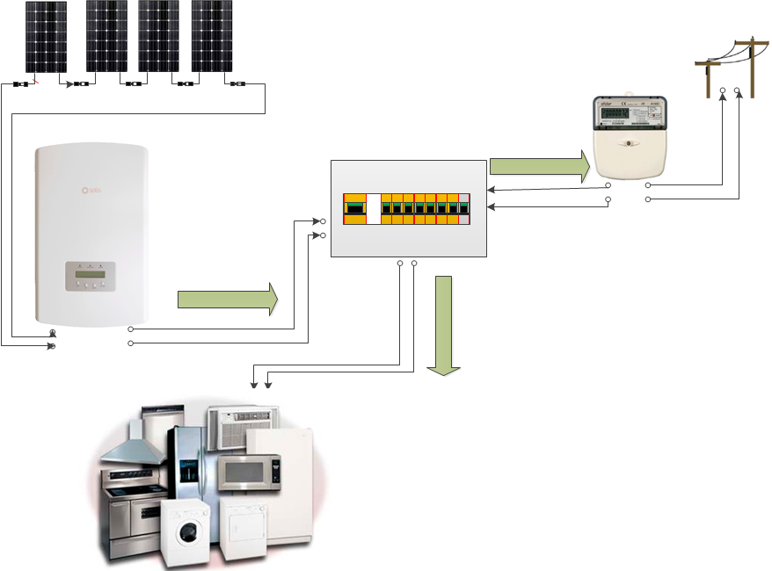
The solar electric panels, or modules, are usually fitted to the roof. The number of modules will depend on the size of your system and, collectively, they are known as the solar array. The solar array converts sunlight into direct current (DC) electricity.

The DC electricity is fed to the inverter which may be either in the loft or downstairs. The inverter converts the DC electricity to alternating current (AC) electricity which is compatible with the electricity supplied to your house from the grid. Inverters have a digital readout so you can monitor information like how much solar electricity is produced, etc. Refer to the separate inverter Owner’s Manual for more information.

The standard meter located in your meter box can be replaced with a bidirectional meter which will measure how much solar electricity is exported from your solar system into the electrical grid as well as the electricity you import from the grid. This would be required if your electricity provider allows payment for export.

During the Night
At night your solar power system automatically shuts down with no sunlight (the inverter goes into "overnight shutdown mode") and the house is powered only from the mains electricity grid.

Loss of Mains Grid Supply
In the event of an electricity grid failure, the inverter will automatically detect this and will shut the system off (shutdown condition). This is an important safety feature is called “anti-islanding” and complies with the EN50438 grid standard with Irish Variants. This prevents possible electrical injuries to the maintenance personnel that may be repairing the mains grid electrical network.

System Performance

During daylight hours, your system will be generating electricity at varying levels depending on the local environment. The more sunlight falling on the solar array the more electricity is generated; therefore variables like cloud cover, seasonal solar angle variations, shading or soiling of the solar array, will have an effect. Note that you need not change your energy usage lifestyle to correspond with your solar system. Your energy consumption will be supplied by both solar and the grid. However, you can reduce the export of power to the grid by timing devices such as washing machines, dishwashers and other devices to operate at times when maximum solar power is available.

The table below shows expected system performance using a 1kW nominal PV array facing south in Dublin at a tilt of 30 degrees.

Month | Ave KwHrs/Day
January | 1.01
February | 1.56
March | 2.5
April | 3.58
May | 4.14
June | 4.03
July | 3.88
August | 3.57
September | 2.86
October | 1.98
November | 1.24
December | 0.78

If you have a 2.75 kw system (say 10 panels, each 275W) you would expect 2.75 times the above figure approximately each day. You can check your daily performance on your inverter and verify that you are getting approximately the power you would expect.

Factors Affecting Performance

- Standard Test Conditions (STC)

PV arrays are rated under standardised conditions, such as specified illumination (1000 W/m2), and specified temperature of 25 "C, these standard test conditions (STC) allow for a uniform measuring of performance between various manufacturers of PV panels. Due to varying factors such as those listed below, performance will vary from manufacturer specified standard test conditions.

2. Temperature and reduced output

PV array temperature affects the output of the entire system. As the temperature on the array surface heats rises, the energy output will decrease.

3. Angle of the sun

The angle of the sun in relation to the PV array surface (orientation) will affect the PV array output. The array energy output will vary depending on the time of day and time of year as the sun's angle in relation to the array changes. Incident sunlight decreases when the sun is near the horizons due to the greater atmospheric air that it must penetrate. This reduces both the light intensity that strikes the array's surface and spectrum of the light.

4. Partial shade

Shading of only a single module of the array will reduce the output of the entire system. Such shading can be caused by something as simple as the shadow of a mains power cable or tree branch on part of the array's surface.

This condition, in effect, acts like a weak battery in a flashlight, reducing the total output, even though the other batteries are good. However, the output loss is not proportionate to shading. Inverters are designed to maximize energy production in all of the above situations.

5. Other environmental conditions

Solar irradiance, wind and cloudy conditions can all affect the performance of a solar power system. Solar irradiance is continually varying throughout the day with a peak level generally around noon or early afternoon. A higher irradiance level will result in higher solar generation. Solar irradiance is also affected by cloud cover, which will substantially reduce the level of solar generation. High wind speeds can enhance performance by reducing the core temperature of the PV panel.

- Other factors that contribute to system losses are:

• Dust or dirt on the array

• Fog or smog

• Inverter efficiency

Solar Power System Start-up Procedure

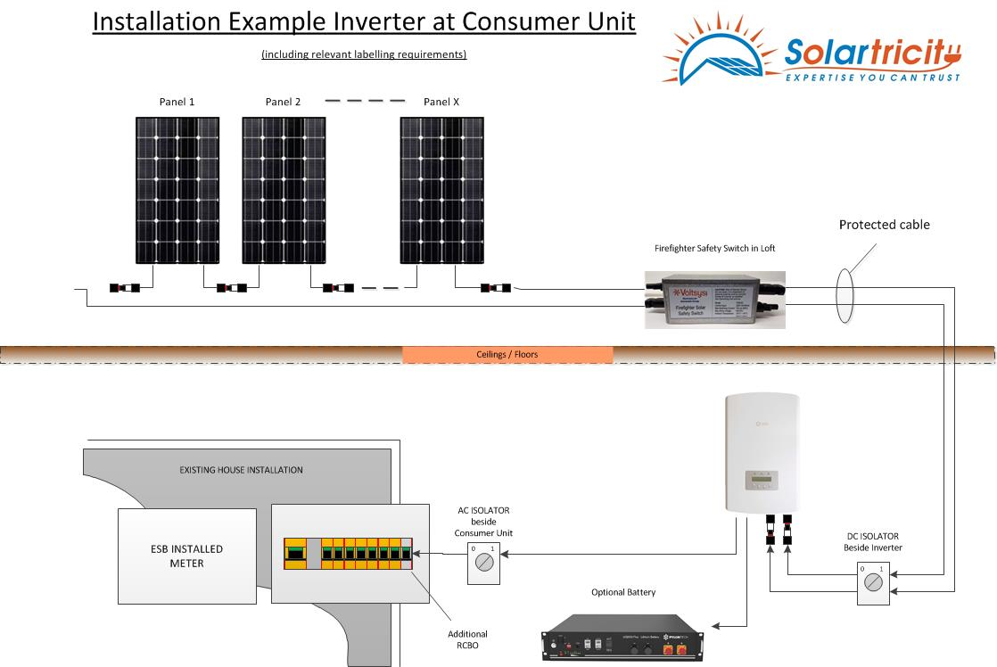

Above is a line drawing of a typical PV system. Your system may have one or two DC isolators, depending on whether the inverter is mounted downstairs or closer to the solar panels.

Your system will have the following switches; MCB in the consumer unit, an AC isolator located near the consumer unit, and a DC isolator, which may be on the bottom of the inverter, or close to the inverter.

Switching system ON

Switch on the AC MCB
Switch on AC isolator
Switch on DC isolator
Switch On Battery (switch button on the battery itself)

After the system is switched ON, the inverter will run through a testing and initialising process. It will then begin correct operation and you will be able to read production etc. on the front screen.

Confirm correct solar power system operation by reading the generated voltage and power values from the inverters LCD user menu, located on the front panel of the inverter.

Switching System OFF
Please follow this procedure when turning your solar power system OFF.

Switch OFF the MCB in the consumer unit.
Switch OFF the AC isolator
Switch OFF the DC isolator (which may be located on the inverter)
Switch Off Battery (switch button on the battery itself)

Operating & Safety instructions

Your solar electricity system is designed for automatic operation with no need for user interaction. There are no moving parts and, apart from normal performance monitoring, there is no need for the owner to intervene in its operation.

In the case of mains grid supply failure the inverter will be automatically and immediately disabled. This is known as anti-islanding.

Once the power has been restored, the inverter will be automatically re-enabled.

If you notice your system is not operating correctly, please call your system supplier and they will arrange to send a technician to resolve the problem.

- Do not attempt to service the system yourself – contact installer

- In the event of an “Earth Fault Alarm” your system should be shut down immediately, if it is not shut down automatically. Please contact Installer immediately to have your system inspected.
- All service work must be carried out in strict compliance with all local and national electrical codes and standards.

- Review and follow all safety instructions supplied with all components of the solar electricity system.

- Avoid working on the system in wet or damp conditions.

- Remove all jewellery such as rings, bracelets, etc. prior to servicing the system to reduce the risk of electric shock.

- The solar array will generate electricity during sunlight. They should be covered or disconnected prior to servicing.

- Do not attempt to clean or come in contact with the surface of a solar module with broken glass. This could result in a dangerous electric shock.
- Be aware that power may be present at any point in electrical circuits despite the opening of circuit breakers.

- Circuit breakers can trip automatically if problems occur. If the circuit breaker is switched back to the closed or “on” position and it immediately trips back to the open or “off” position an ongoing problem is indicated.
- Do not substitute materials supplied with the solar electricity system.

- Appropriate precautions must be taken when working on rooftops or at heights in accordance with local and national occupational health and safety regulations.

Maintenance

Your solar power system requires little maintenance, as there are no moving parts to fail or adjust. For your safety, we do not recommend that you attempt any self-service unless you are suitably qualified.

The solar panels work best when clean. In Ireland, regular rainfall will ensure that panels are kept clean provided there is a slope on the panels. However, if they become soiled by bird fouling or foliage, they can be cleaned with cold water. It is recommended to check that the solar panels have minimal shading from new vegetation or surrounding objects.

We strongly recommend that you do not climb onto the roof, unless you are qualified and trained in occupational health and safety procedures.

Plant and tree growth that can cause shading at different times of the year should be monitored and dealt with. Likewise, leaves and other debris coming to rest on the solar modules should be removed.

If you notice your system is not operating correctly, please contact us immediately and we will send a technician to resolve the problem. If you need to shut down the system, please follow these steps in the “Solar Power System Shutdown Procedure”

- Switch off the Solar Supply Main Switch in the main switchboard or meter box.

- Switch off the AC isolator (if supplied), and then the DC isolator adjacent to the inverter.

Following these steps will isolate the solar array. To switch it back on, you simply reverse the procedure.

Always remember that your system will be generating electricity during daylight hours and care should always be taken to eliminate the risk of electric shock.

The following maintenance schedule is recommended

Weekly | 6 Monthly | Yearly
Check to make sure the inverter is working correctly by checking the LCD screen, or by checking online monitoring if you have a wifi enabled monitoring system  Check the inverter operation (e-today, e-total etc.) to verify that production is consistent with the prevailing weather conditions and system size | Check for vegetation growth that may be shading the panels and cut back if required  Visually inspect the panels for any damage | Visually check that the PV array and mountings are firm and show no corrosion or damage  Visually inspect the inverter for build-up of dust and clean with a dry cloth if required.

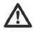
DANGER: The inverter operates at very high voltages. There is risk of fatal electrical shock if the inverter is opened during use. The inverter must only be opened by technicians for either maintenance or modifications.

DANGER: Do not touch or pull any of the electrical wiring cables around the inverter. Do not remove the front cover of the inverter. Do not switch the system on if there are damaged or exposed electrical cables due to risk of fatal electrical shock!

DANGER: Do not touch or come in contact with a solar module if it is found to be broken or has cracked glass, as this could result in a fatal electrical shock.

WARNING: We recommend using professional services when working at heights. It is recommended that only qualified personnel who are trained and hold current certification attempt maintenance activities on roofs due to the potential hazards when working at heights.

- Warranty

Your solar electric system comes with the following warranties:

- Solar electric modules – 10 Years on Manufacturing, 10 years limited warranty of 90% power output, 25 years limited warranty of 80% power output
- Inverter – 5 Year Standard extendable to 10 years at additional cost

- Roof mounting frames – 10 year standard

This warranty does not cover the following conditions:

- Your existing electrical installation, wiring, and switchboard or fuse box.

- Any malicious damage.

- Any damage caused by vermin, animals or pests.

- Any consequential or other loss suffered by you in connection with the installation of our products or our products failing or breaking.

- Any damage to your property (other than products we sold you) caused by our products failing or breaking.

Warranty Exclusions

These conditions shall cause the system warranty to become void.

Any work associated with rectification of these conditions may incur a service charge and costs for parts should they be necessary.

- Any service required to electrical wiring. Major variations or faults in electrical energy supply, causing damage to the Inverter or other supplied equipment.

- Accidental breakage is not covered by this warranty, and should be added separately to your general household insurance policy.

IMPORTANT REMINDER

Please keep this owner’s manual in a safe and easily locatable place together with all other documentation supplied with your system.

In the case of a service being required, please supply all the documentation to the service technician as the information contained therein will be useful to that technician. Note that the manufacturers’ warranties may be voided if the system is serviced or interfered with by an unqualified person.

______________________________________________________________

